**Book Questions**

**Chapters 5**

Devayan Mandal

5.2. How might you use a model of a system that already exists? Explain why it is not always necessary for such a system model to be complete and correct. Would the same be true if you were developing a model of a new system?

Ans:

**How might you use a model of a system that already exists?**

The implementation of an existing system model may arise in several cases which may include implementing an existing system again, modifying; more specifically improving current system modalities and teaching or exchanging information regarding the current system with newly recruited system engineers.

**Explain why it is not always necessary for such a system model to be complete and correct.**

An existing system does not have to be complete for several reasons which may include the following:

* If the situation only requires teaching or exchanging information without formal written documentation.
* If only select existing system modalities require redesigning.

**Would the same be true if you were developing a model of a new system?**

The model of an existing system could be used to create a predominant number of new systems provided the requirements and output of the new system match those of the existing system. A scenario where design and creation of a new system would be required is when the system development approach used explicitly dictates creation of a new system from the beginning.

(next page please)

5.5. Develop a sequence diagram showing the interactions involved when a student registers for a course in a university. Courses may have limited enrollment, so the registration process must include checks that places are available. Assume that the student accesses an electronic course catalog to find out about available courses.

Ans:

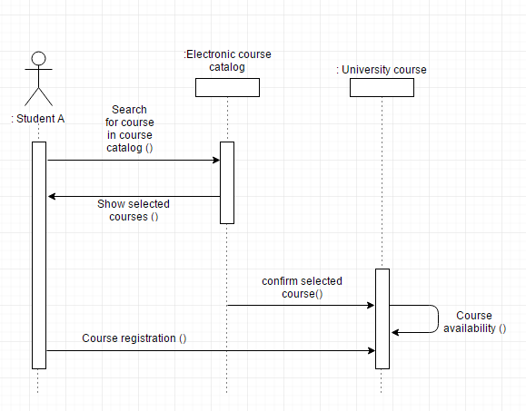

5.6. Look carefully at how messages and mailboxes are represented in the email system that you use. Model the object classes that might be used in the system implementation to represent a mailbox and an email message.

Ans:

|  |
| --- |
| Email (Gmail) |
| From:  To:  cc:  Date and time:  Subject:  Mailed by:  Signed by:  Encryption:  Message Body:  Attachments (if any:) |
| Reply  Reply All  Forward  Filter messages like this  Print  Add____ to Contacts List  Delete this Message  Block “__________”  Report Spam  Report phishing  Show original  Message text garbled?  Translate message  Mark as unread |

5.7. Based on your experience with a bank ATM, draw an activity diagram that models the data processing involved when a customer withdraws cash from the machine.

Ans:

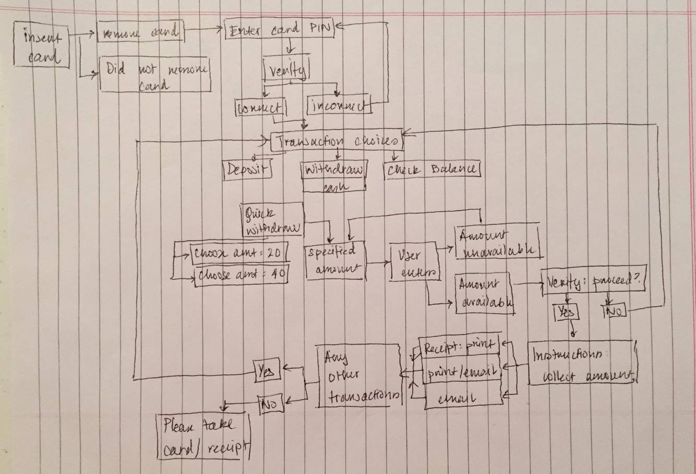

5.10. You are a **software engineering manager**, and a **senior member** of your team proposes that **model-driven engineering** should be used to **develop a new system**. What **factors** should you take into account when deciding whether or not to introduce this approach to software development?

Ans:

If I were a software engineer manager, I would try to implement an **analytical approach** to ascertain whether a model-driven engineering approach is required to develop a new system.

* A primary concern would be to ensure that a **majority** of the **current software development team** **proposed** the model-driven engineering model and not just a select few. Training a team who is not familiar or not interested in the approach would pave a path towards failure.
* A model-driven approach may **introduce** a **greater level** of **rigidity** in regards to the **development of software**. In such cases, **components** of **software development** should be **assigned** to **members** of the team to **manually code**.
* Obtaining an **accurate financial budget** before **implementing a new system** would be crucial to ensure that the team **does not exhaust** it's **financial** and **software resources**.
* Like **realistic cost estimation**, analysis of the likelihood of using the model-driven approach should be assessed and should only progress forward if the **approach** agrees with the **team's cumulative long term goals**.